OFFICE of CONTRACT and GRANTS
DIVISION OF RESEARCH
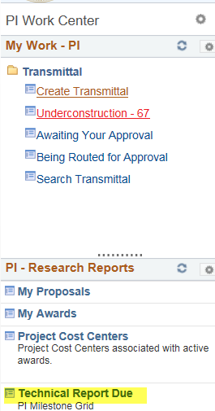

PI Work Center - Technical Reports Due
The Technical Report feature in the Work Center allows PIs to view outstanding technical reports, and upload and submit them to OCG. This is not a mechanism for submitting the reports to the sponsor. The feature simply allows The university to comply with this monitoring requirement for audit purposes. The report link is located in the left column of the PI Work Center. PIs with faculty titles/assignments can access the PI Work Center via the AccessUH PI Portal.

The PI must click on the Technical Report Due link, to display the PI Milestone Grid that displays all outstanding technical reports. Each report line has a View Documents button that the PI can select in order to upload the report or evidence that the report has been submitted to the sponsor.

Prior to uploading the report, the Approve button will be grayed out. After uploading the document(s), the Approve button will be available for the PI to select and submit the report to OCG.

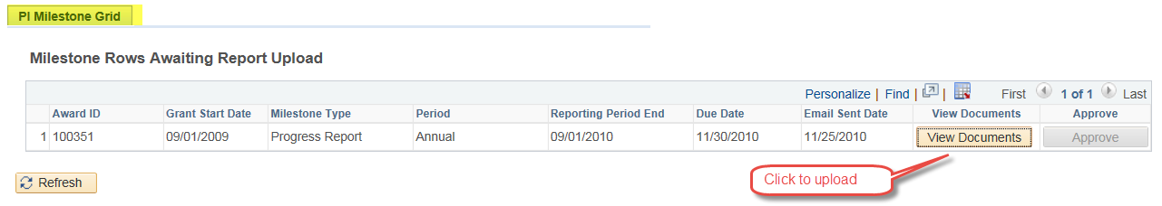
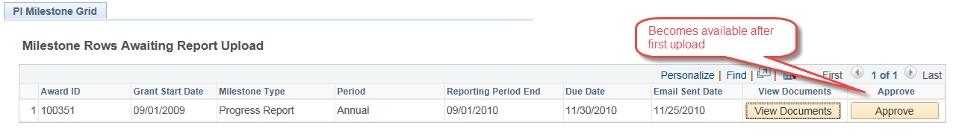

The PI can upload as many documents as necessary for each report. The file formats allowed for uploads are
CSV .DOC .DOCX .PDF .PPT .PPTX .TXT .XLS .XLSX

