Workflow for Obtaining Gulf of Mexico
Geological & Geophysical Data from BOEM and BSEE

by Sharon Cornelius, PhD

Updated March, 2018 to account for website changes made in April, 2017

Introduction

The Bureau of Ocean Energy Management, commonly referred to as BOEM, is one of the two re-organized and re-formulated versions of the former Minerals Management Service (MMS) agency. The other agency is the Bureau of Safety and Environmental Enforcement (BSEE), where the purchase of this data can be made. It is necessary to register with BSEE before purchasing, but there is no fee associated with the registration; and it is advisable to register before attempting searches on the vast website, so that any items discovered in the search can be added to the shopping cart at the time you find them, rather than having to search for them again.

If looking for well data, specifically well logs, it would be helpful in reducing the time required for a meaningful search, that if before going to either the BOEM or the BSEE website, the specific lease area of the Gulf of Mexico and block number(s) be determined. It is not necessary to know the company operator or the API well designation ahead of the initial visit to the site, this information can be obtained within the site itself. Without knowing the lease area (such as Alaminos Canyon, etc.) or the block number where the well is located (block 52, etc.), will cause a general search and greatly increase the time required to find any potential data.

If looking for seismic data surveys, the options have diminished considerably since April, 2017. Most of the government 2D and 3D seismic data in the Gulf of Mexico has been transferred to a private company in California named Earth Science Associates. It is available to students and faculty at no cost provided that the data is used for academic purposes only. Check their company website:
http://www.earthsci.com/gom3.php

Outline

I. How to find Seismic data………………………………………………………………………….p. 1

II. How to find Well Logs or other borehole data…………………………………………………..p. 5

III. How to Register ………...…………………………………..........................................……….p. 11

IV. How to Check Out when Purchasing Data .........................................................................p. 12

However, there are some seismic premade data sets available on CDs and in order to view the list of
these data sets, first click on this link:

http://www.boem.gov/Oil-and-Gas-Energy-Program/Resource-Evaluation/Geological-and-Geophysical-Data-Acquisition/GGData-Gulf-of-Mexico.aspx

and here the image on the website should appear the same as that in Figure 1.

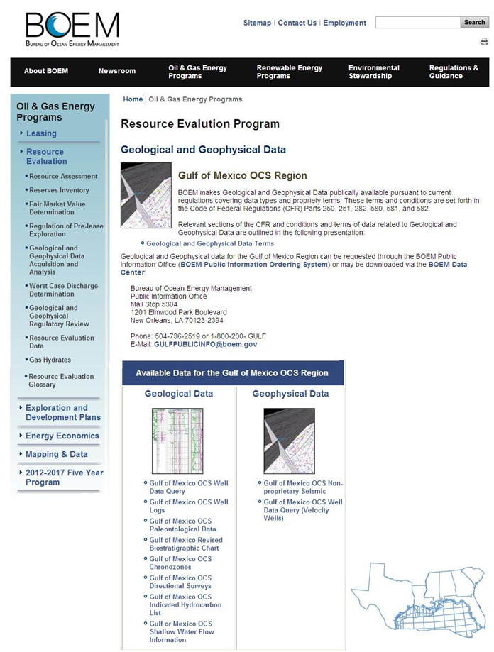
Click on this link and it will take you to the screen in Figure 2.
Figure 1.

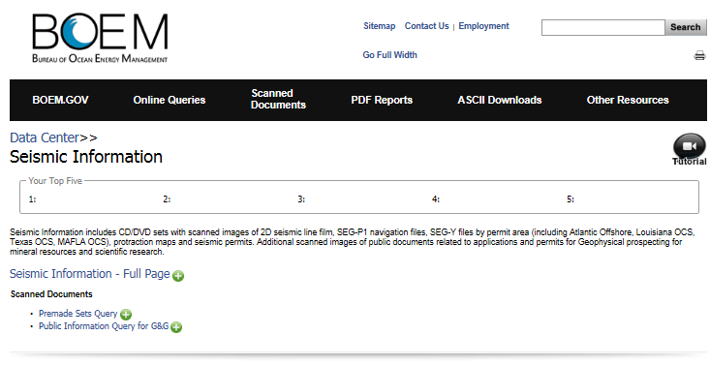
Figure 2.
Clicking on this link will not produce any additional information; it has been deactivated due to seismic data removal.

Clicking on this link will lead you to list seen in Figure 3.

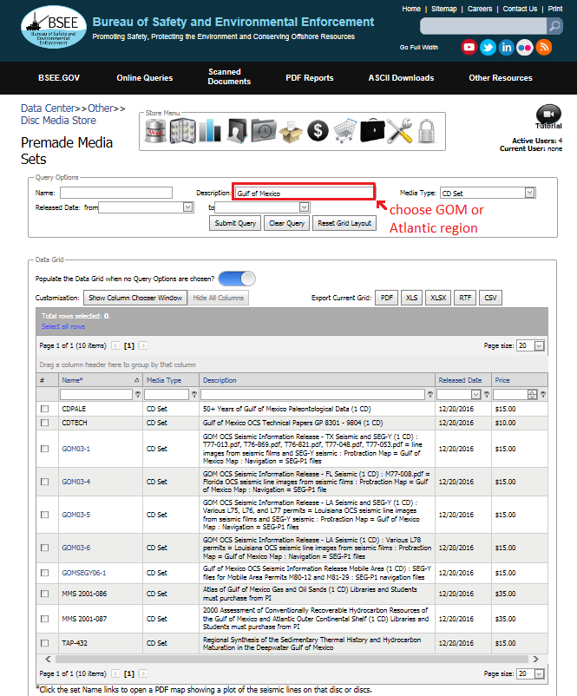
The list of available premade seismically related data sets and geologically related data sets. Note that if you switch to DVD instead of CD in the Media Type box at the top, there is nothing in that list.
Figure 3.
Clicking on the file name in the left hand column will bring up a map showing where the seismic lines are in the set. There is no preview of the actual data within the dataset and this is true of well log data as well. If you wish to purchase any item in the list found in Figure 3 while online, check the box next to the item and be sure you click on “add to cart” button at the top of list before leaving the page. See Figure 4 below.

Figure 4.

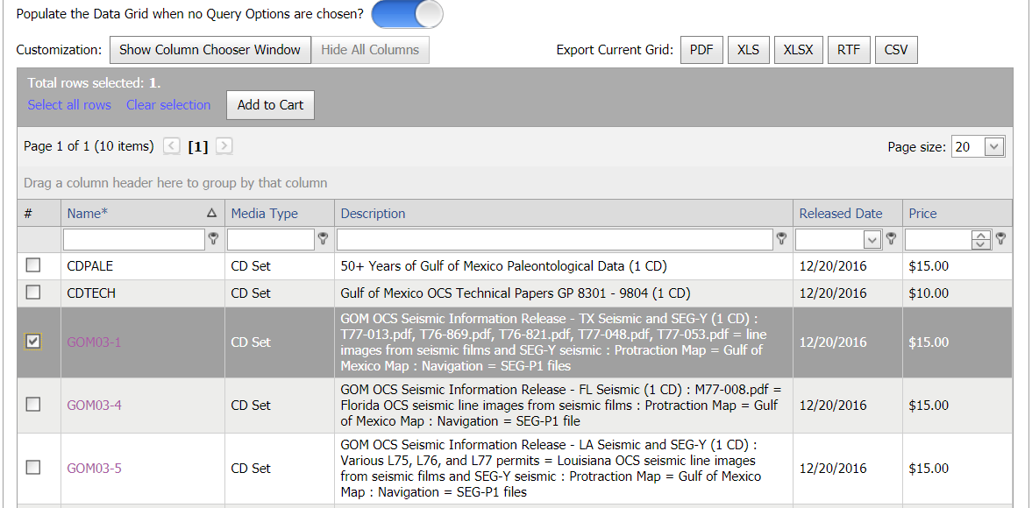

How to check for Geological and Geophysical information availability for Gulf of Mexico specific block areas

The link below will take you to the current government website where this data is available to the public to purchase for a minimal fee: https://www.data.bsee.gov or https://www.data.boem.gov. Either link will produce the same screen, the image on the website should appear as that in Figure 5.

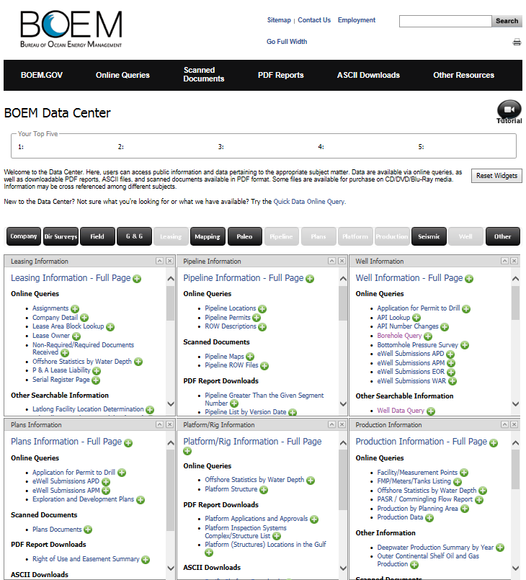
Clicking on the tutorial will show you how to use the “widget” boxes below.
Figure 5.

To see the full list of options for whichever category you are interested in, go to the top of the “widget” and click on “Full Page”. Assuming you are interested in Well Information, clicking on the Well Information - Full Page title will bring up the screen in Figure 6.

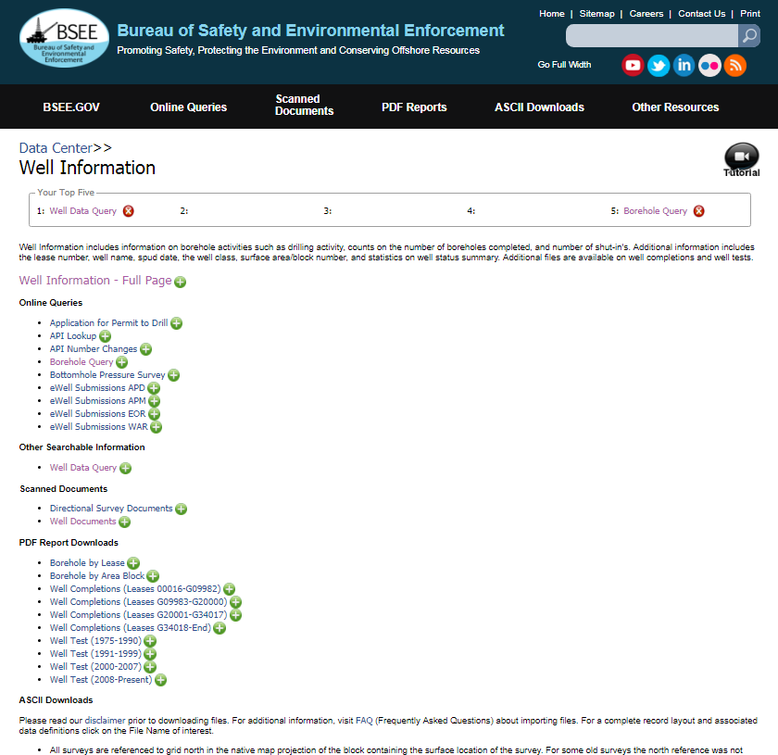
The 2 most useful categories are Borehole Query and Well Data Query. What is the difference? The borehole query will give you the coordinates of the well location, the depth of the well in terms of measured depth and the true vertical depth (TVD), the Kelly bushing (KB), the water depth, the API number and the well name for all wells within the block, unless you specify a particular well.

The well data query will give a list of all the log types that are available for each well and will tell you if there is a velocity survey, a deviation survey, or if there is paleontological data available.

Figure 6.

An example of the screen for Borehole Query is shown in Figure 7.

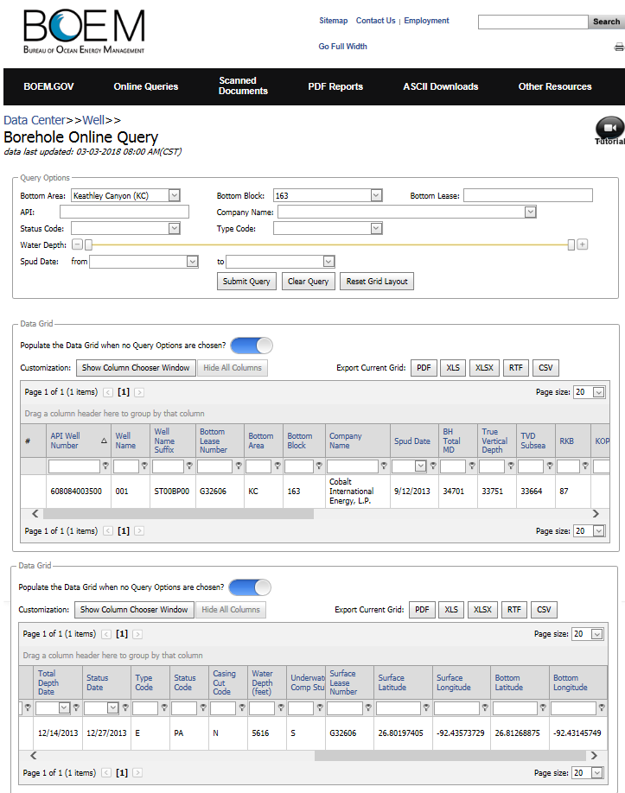
Figure 7.
Click on Submit Query after you have selected the area and block number.
Information on right side of screen
Information on left side of screen

An example of the screen for Well Data Query is shown in Figure 8.
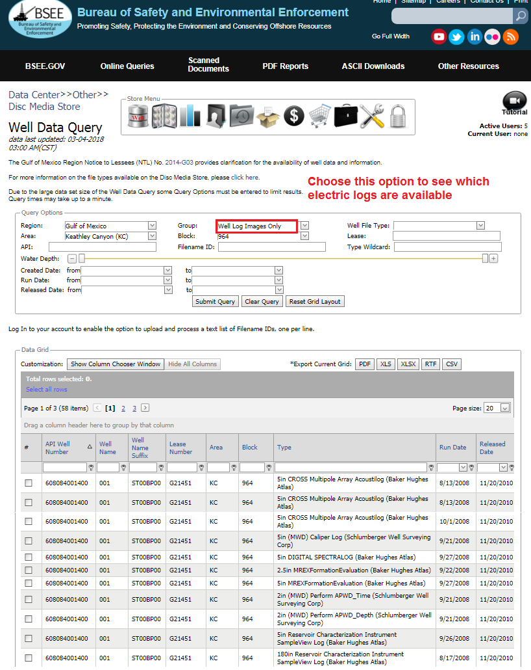
Figure 8.

If you toggle the bar at the bottom of the chart to the right, you will see two columns labelled BLI and TLI. BLI stands for “bottom of log interval” and TLI stands for “top of log interval”. Both numbers will be in feet and refer to depth in the borehole from the top of the rig (or Kelly bushing). Pay attention to these numbers to be sure they cover the interval you are interested in...especially in deepwater environments as logs tend to cover only a small portion of the borehole. You may have to order several logs of the same type in order to get the borehole coverage you need.

By switching to the “Well Data Only” selection, the screen will show what is available for that well, as seen in Figure 9 below. If there were a velocity survey or a paleontological report for this well, that information would show here.

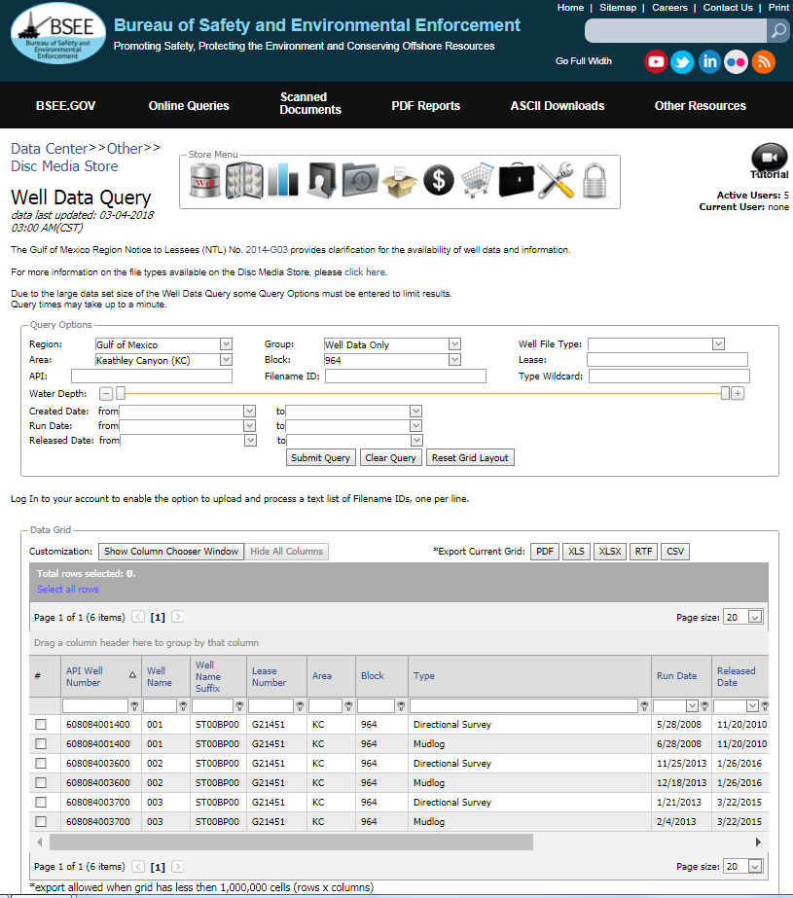
Figure 9.
Once you have made all your selections and entered them into your shopping cart, you may check out provided you have registered. It is recommended that you register before shopping for data.

How to Register

While you are in the screens of Figure 8 (Well Data Query), you will notice the Store Menu bar as shown below:

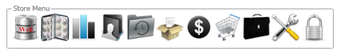
Click on the icon circled in red: it is the My Account button and then the following screen appears:

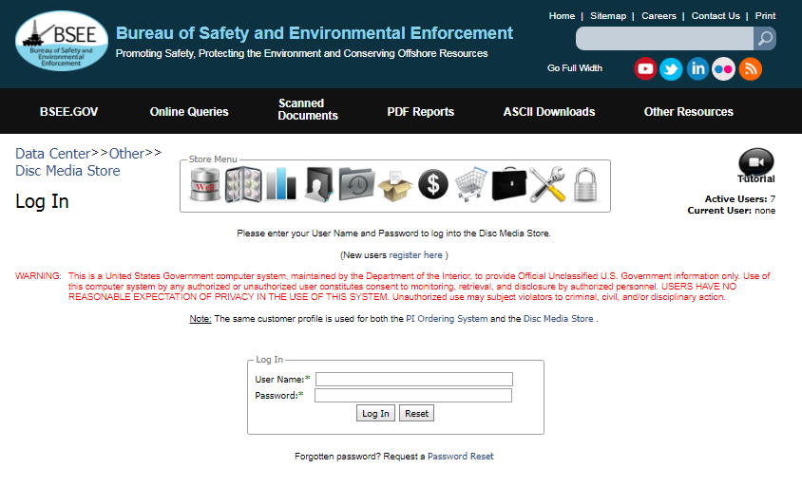
Click here to set up an account
Figure 10.

If you are a student, give your business address as the University of Houston and then your home address (or wherever you want your data shipped) for the shipping address. Data usually arrives by US mail within 3 working days. It will be shipped from BSEE headquarters in New Orleans, Louisiana.

Once you have set up an account, you can proceed to check out, if you have items in your shopping cart.
For instructions on how to add your data items to a shopping list, see Figure 11.

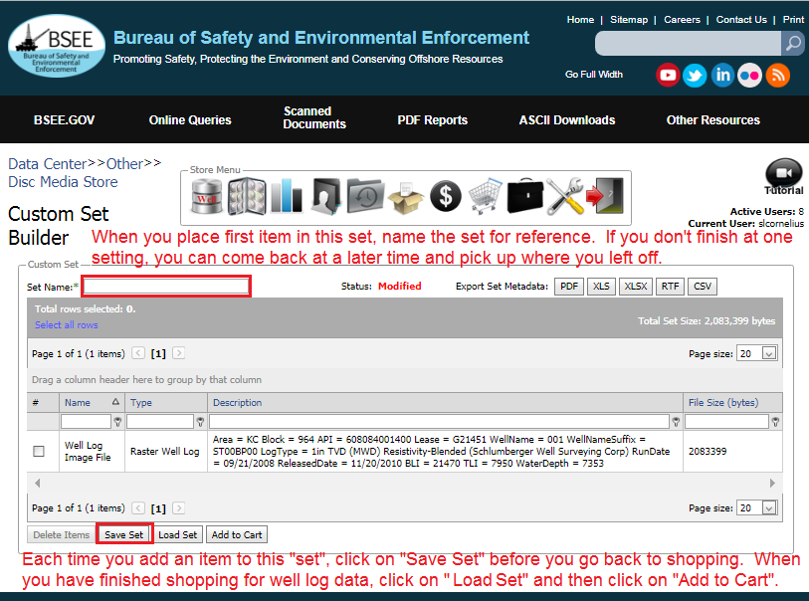
Figure 11.

How to Check Out (purchase your data)

Whether you only have one item in your shopping cart or 100 items, the procedure is the same....just be sure you have enough credit on your credit card to pay for whatever you are buying. Sometimes your data will be too extensive in terms of megabytes or gigabytes to put onto a CD and you will have to switch to a DVD instead, which is more expensive. Overall, data is very inexpensive and it is truly amazing what you can buy for only $15 to $20. The price you pay for the DVD or the CD includes the shipping cost by mail.

The procedure here is similar to buying other merchandise online.

